HY-TB4DV-KH(KL) 4-axis drive board manua
Thank you for choosing our company's products, the use of CNC products better and faster for you, please read this manuaI
Features: Features
1: can be equipped with an external pulse handle with digital display, with the handle can automatically switch the computer and handle control, mutual non-interference, shielded handle control functions automatically and automatically detect the computer-controlled movement, the digital display can simultaneously track record computer data and handle controlmobile data
2: the path of the computer tracking records, time records can be run in the computer processing to save the processed data off-line automatic repeat the processing run
3: Manually move the processing and record keeping, traceability records manually move the machine data, and automatically repeat the process run manually move the path.
4: manual data input processing path, and run automatically enter the path .
5: The driver XYZ-axis or Z axis of the knife can be done automatically, without complex computer software operation
6: up to 3.5A stepper motor drive current, adjustable.
7: up to 16 segments, more accurate, run more smoothly.
8: overload automatic protection function of the flow through the warm, protect your computer and peripherals .
9: bipolar constant-current chopper drive, low speed creeping phenomenon, noise, non-resonant region.
10: a closed optical isolation, two-stage signal processing, to fully protect your computer and equipment.
11:1 the road 0-10V/PWM governor signal output .
12: Rd input control, you can set the limit stop, which is divided into the knife.
Electrical properties (ambient temperature Tj = 25 ℃):
Input power | 12 - 36V DC power supply
Output current | 3A (peak 3.5A)
Driven approach | Bipolar constant-current PWM drive output
The drive motor | 42,57,86 stepper motor, two-phase -4 phase (4-wire, 6 wire, 8 wire stepper motor)
Weight | About 300 g.
Breakdown of table:
Current | SW1 | DW2 | Buffer | SW3 | SW4 | Sub | SW5 | SW6
100% | ON | ON | 25% | ON | ON | 1 | ON | ON
75% | ON | OFF | 50% | ON | OFF | 2 | ON | OFF
50% | OFF | ON | 75% | OFF | ON | 8 | OFF | OFF
25% | OFF | OFF | 100% | OFF | OFF | 16 | OFF | ON

Signal waveform and timing
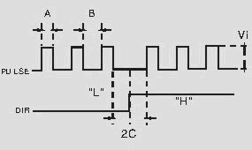
Power output interface functions
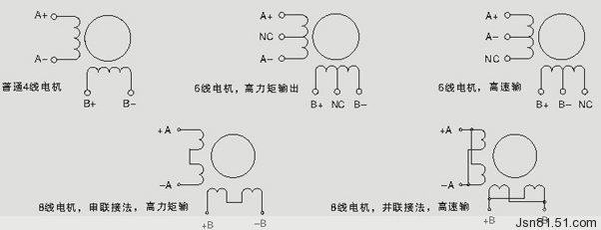
Interface marked detail in Figure
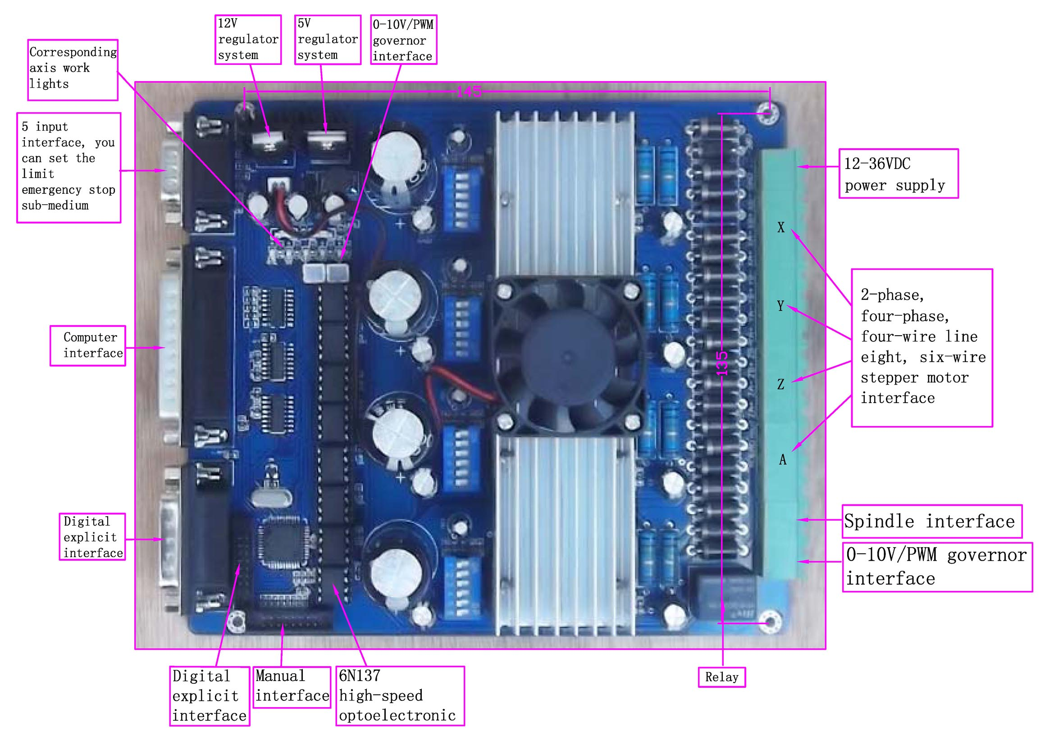
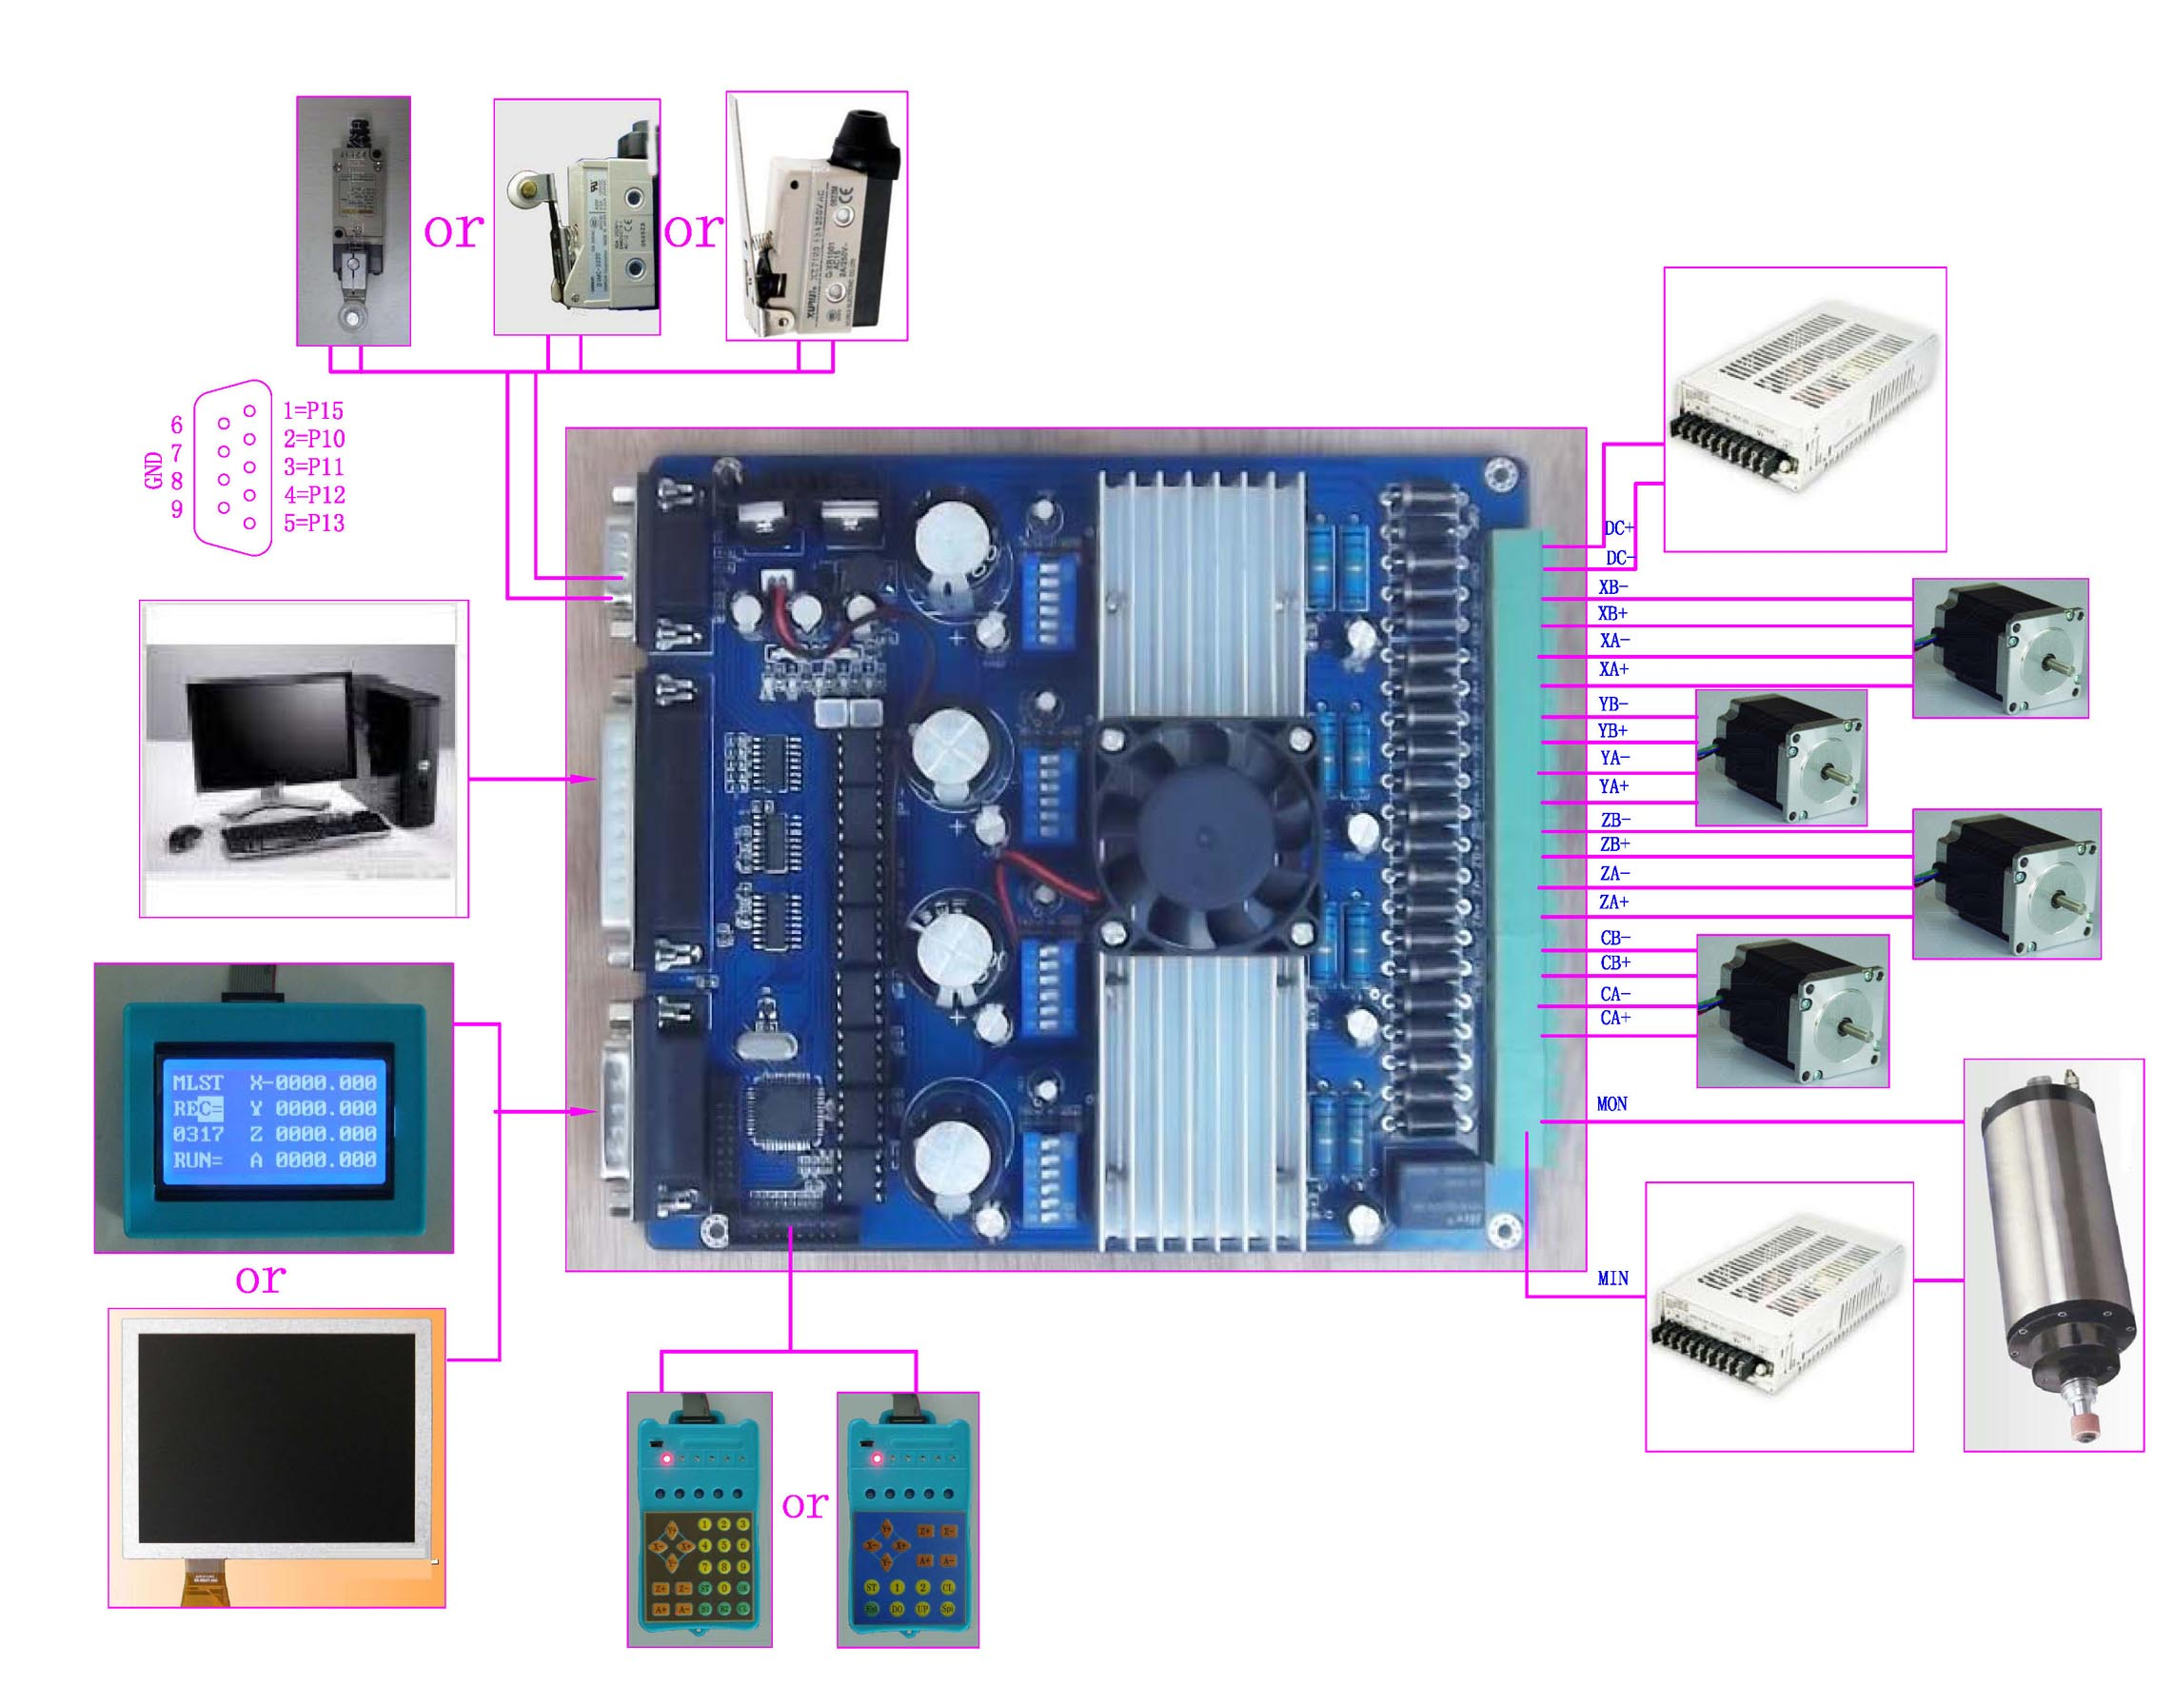
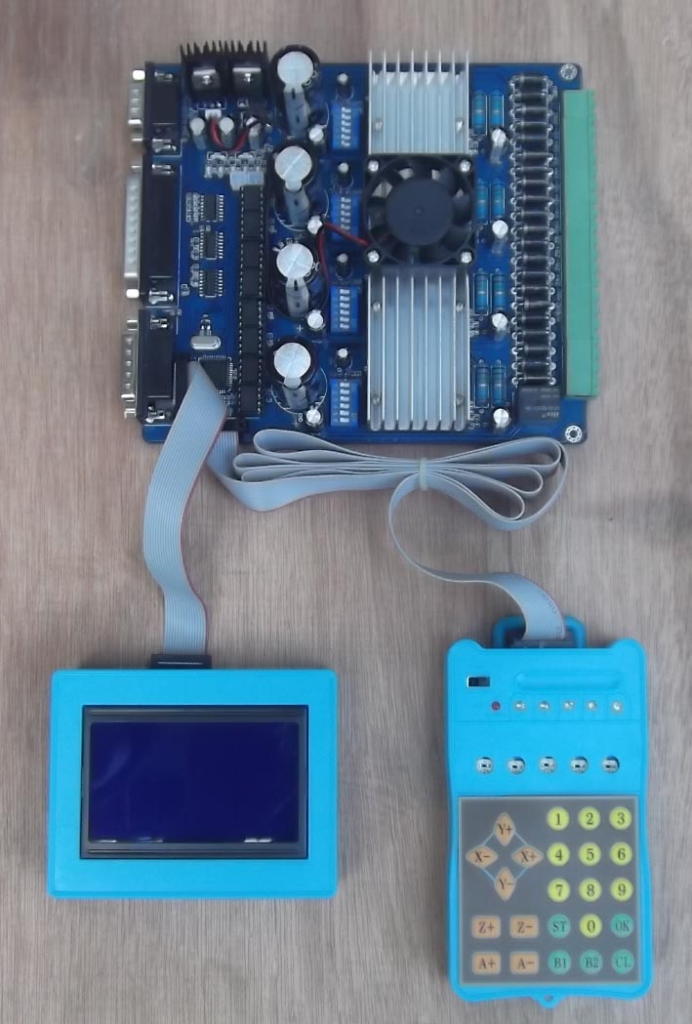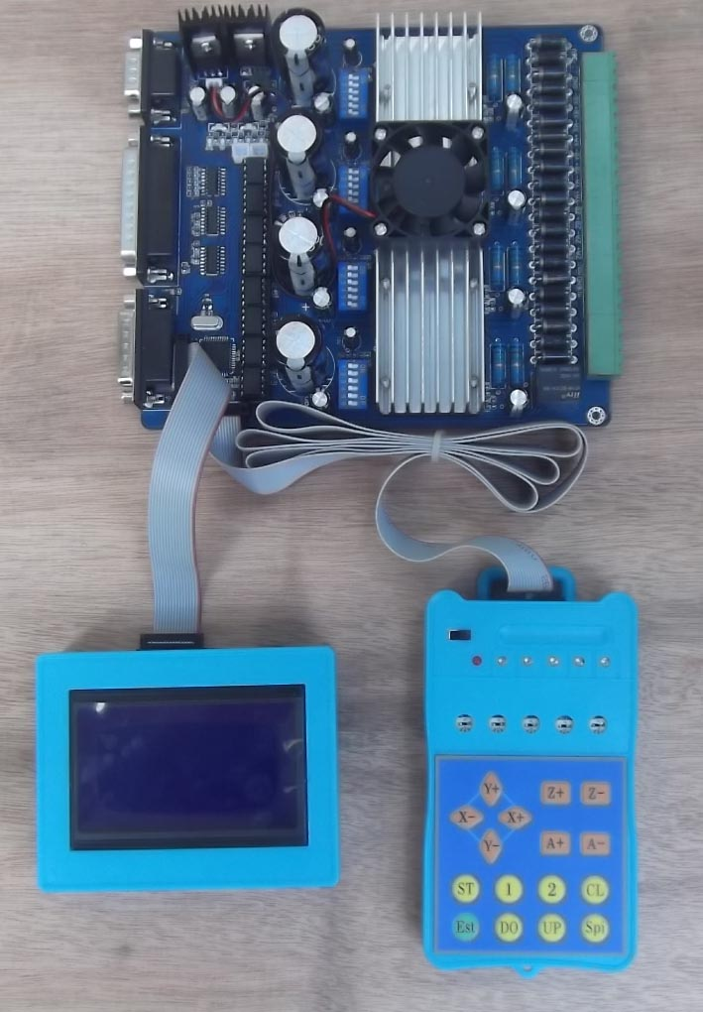
Instructions:
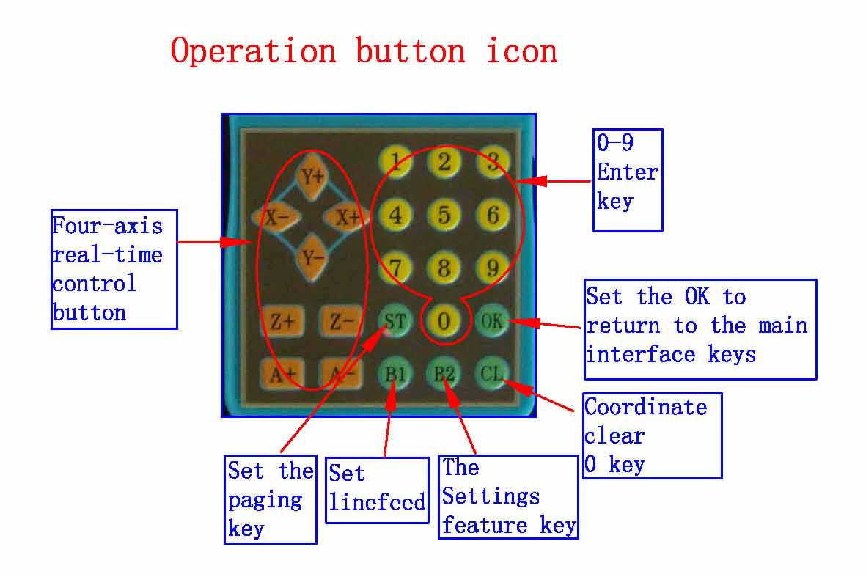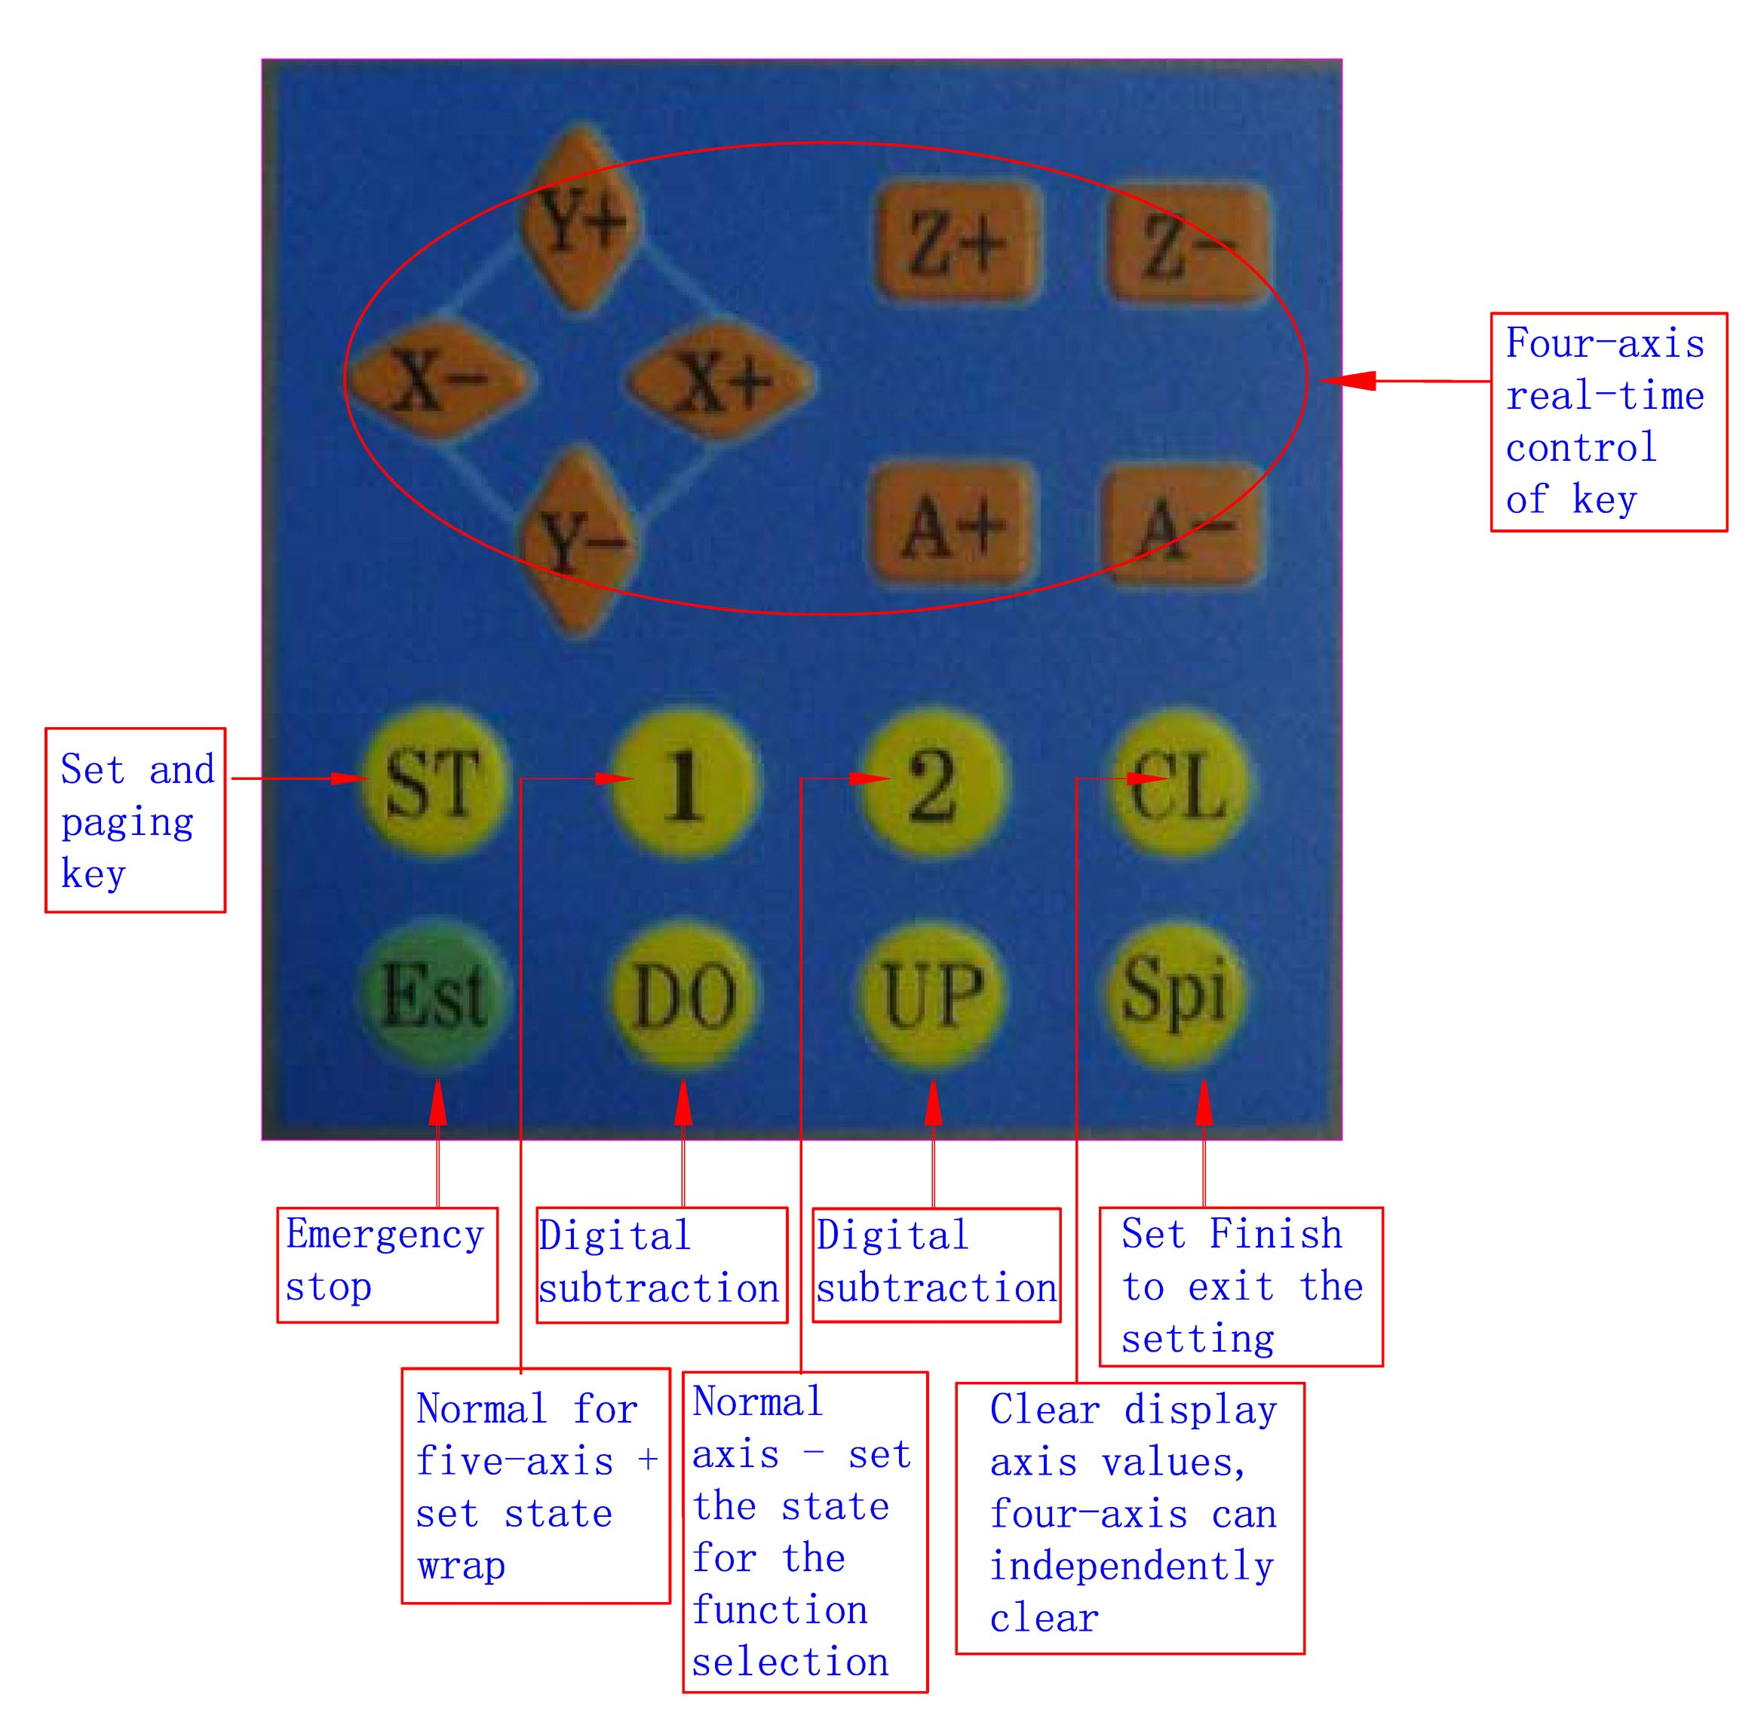
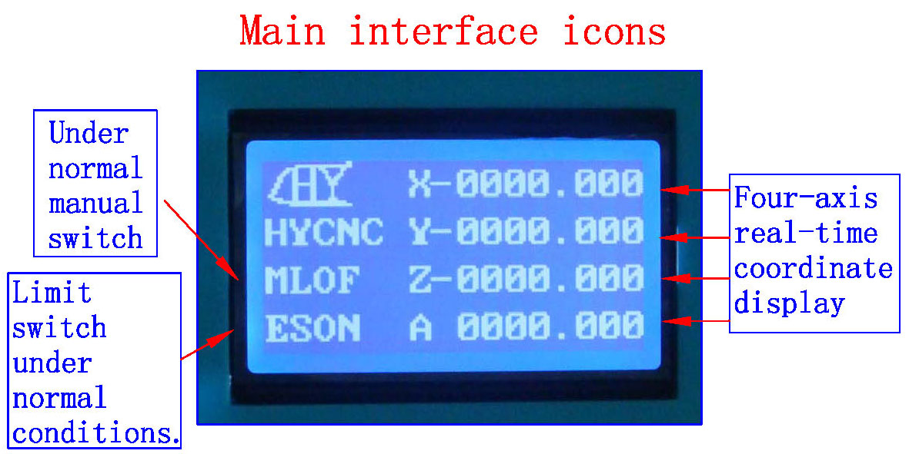
1: The coordinates of display range 9999.999/-9999.999
2: automatically records the computer running coordinates and manually move the coordinates
3: Automatic switch between computer and manual control
4: computer-controlled automatically shielded manual control functions, two seconds after the return to manual function
1: ST button to press the handle into the lower-level setup menu, the setup is complete press the OK button to return to the main work interface
2: Press the corresponding axis of the handle CL button four axis clear 0, according to the B1 replaced a line, press the OK button to exit the clear 0
3: The four-axis real-time recording computer running coordinates and manually move the coordinate value of the computer running data + manually move data
===================================================
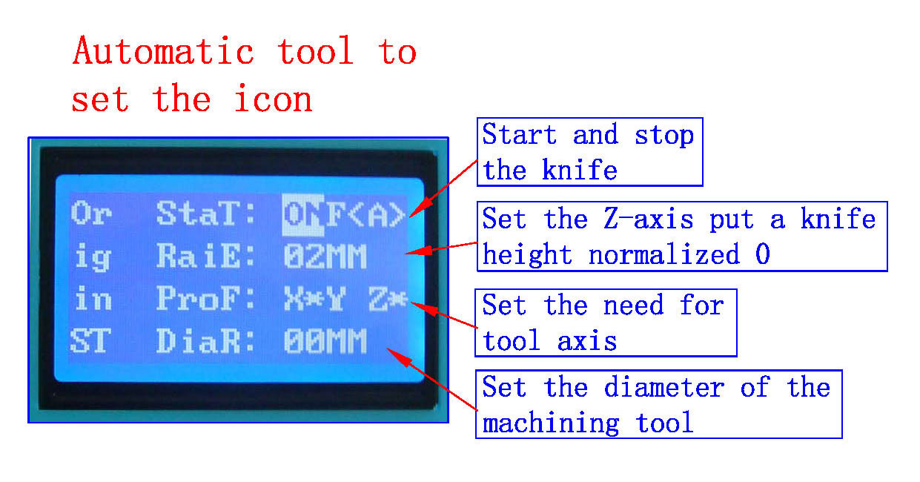
1: all settings automatic permanent preservation until the next set of updates
2: You can set the radius, put a knife height parameters
3: The driver auto-complete the knife, without the complexity of computer software operation, convenient tool change school knife, boot knife, batch processing adequately protected on the knife and other processed products correctly
1: In order to ensure the accuracy of the knife, the knife before check put a knife to the height of the parameters of the tool diameter is set correctly,
2: the need to make sure the knife instrument wiring and limit switch wiring status is normal.
3：B2 keys and press to confirm OK to enter the automatic tool operation and automatically stop after the completion of。
4: Press the keyboard (A-) exit status of the school knife
====================================================
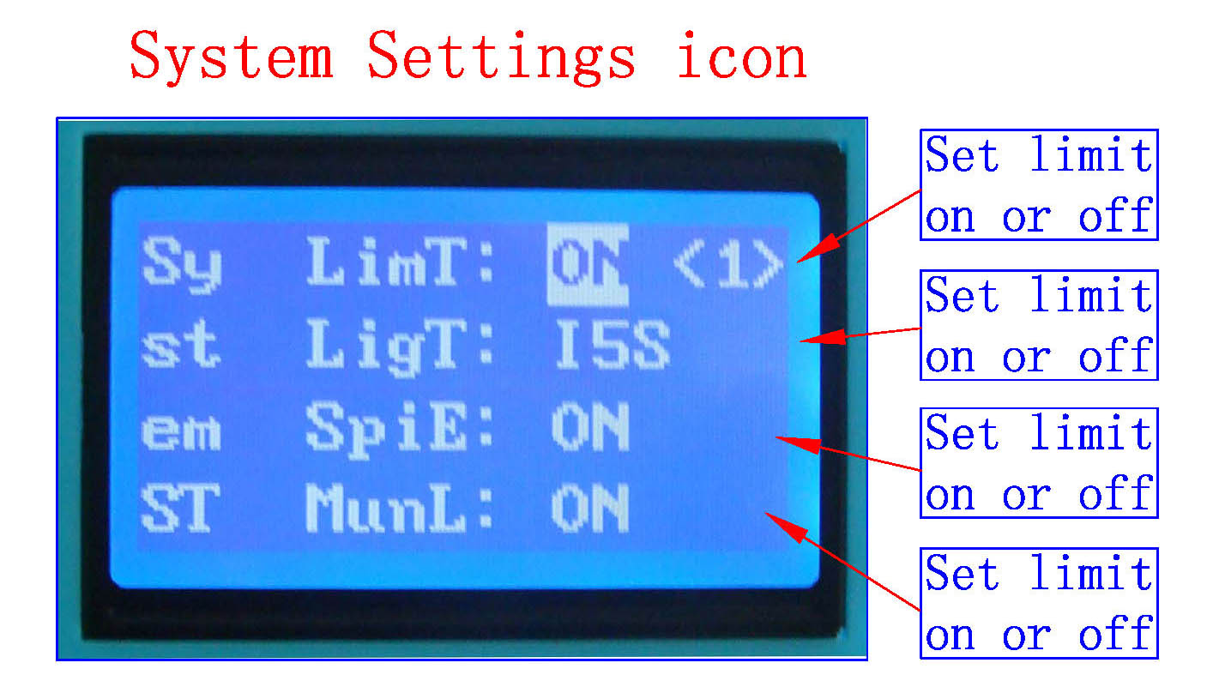
; All settings automatically saved permanently, until the next set update
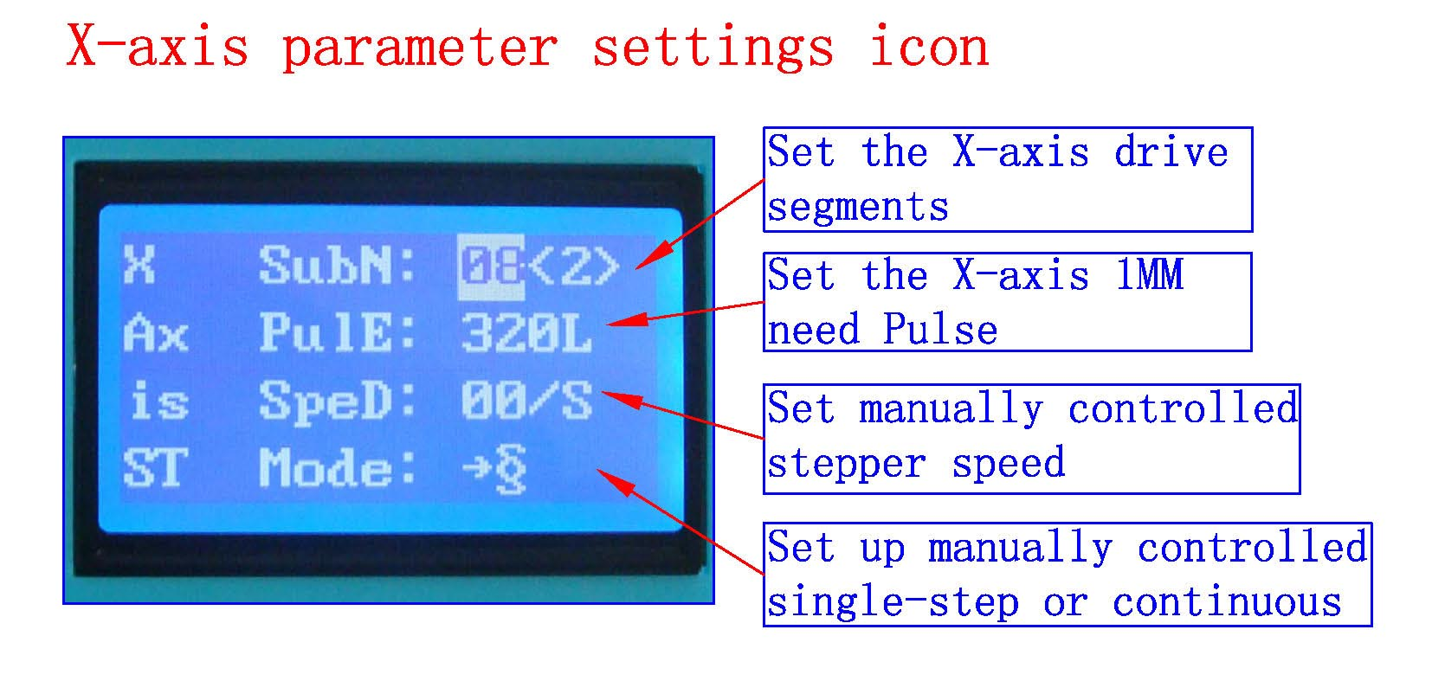
; All settings automatically saved permanently, until the next set update
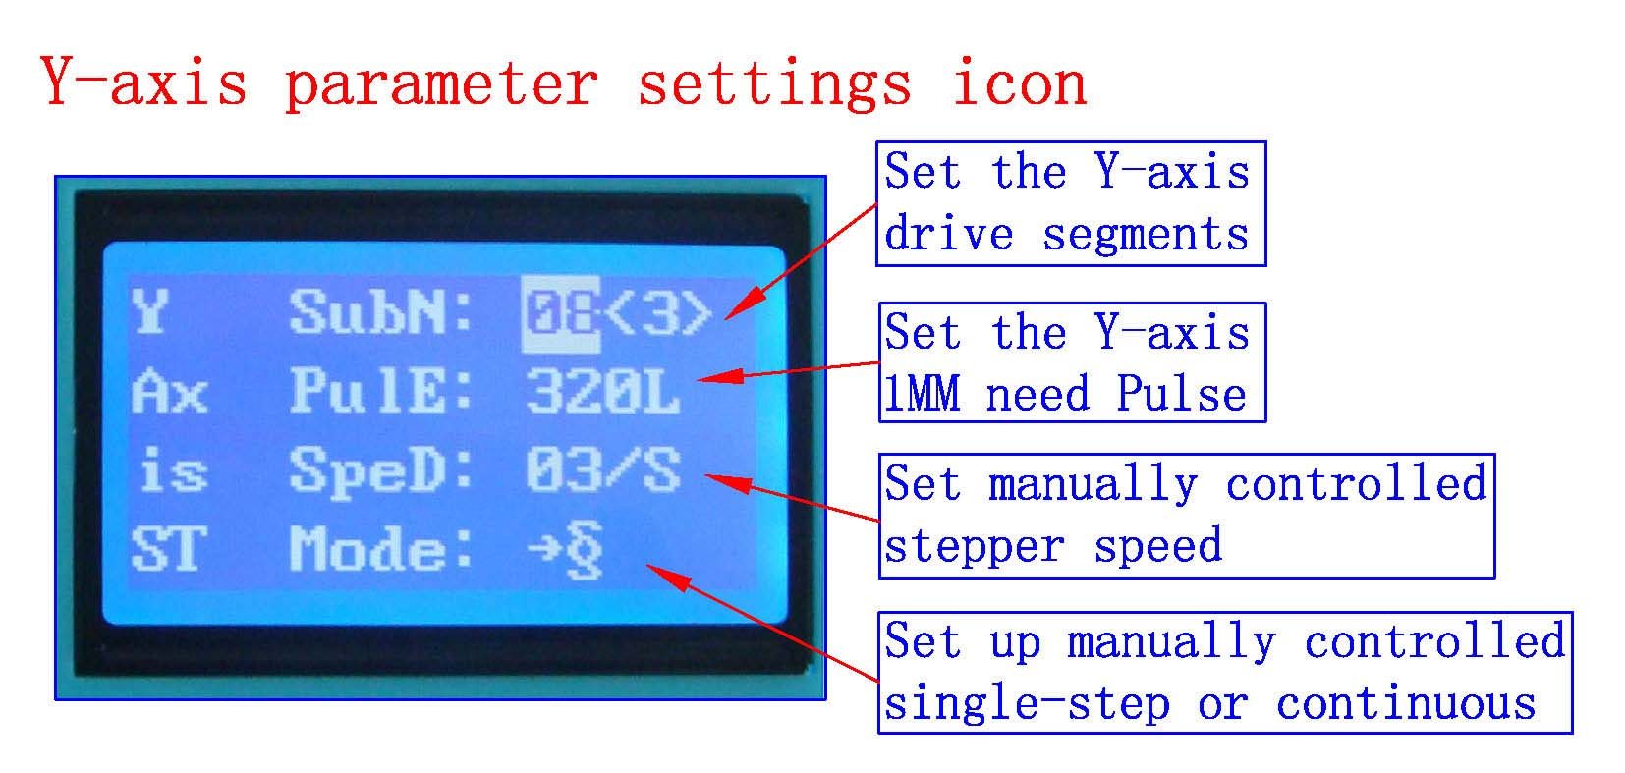;
; All settings automatically saved permanently, until the next set update

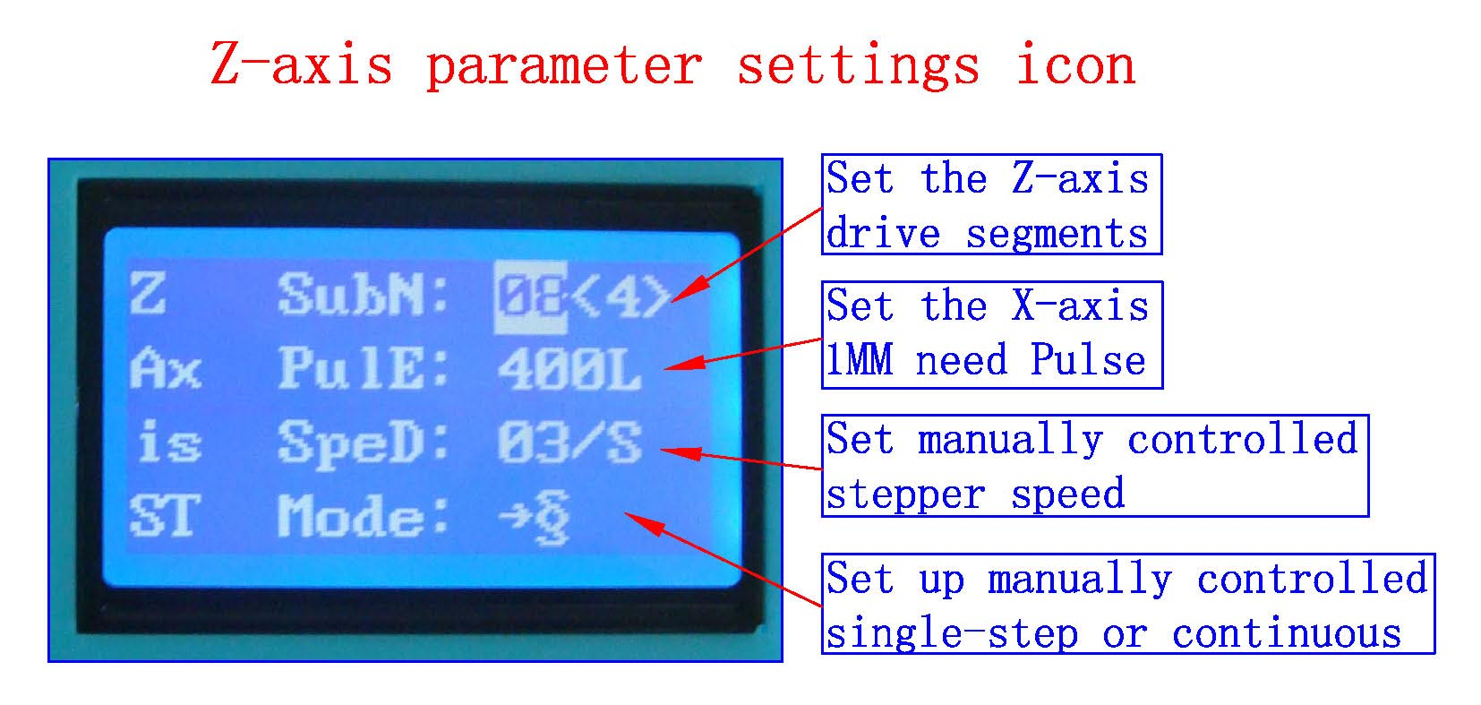
; All settings automatically saved permanently, until the next set update
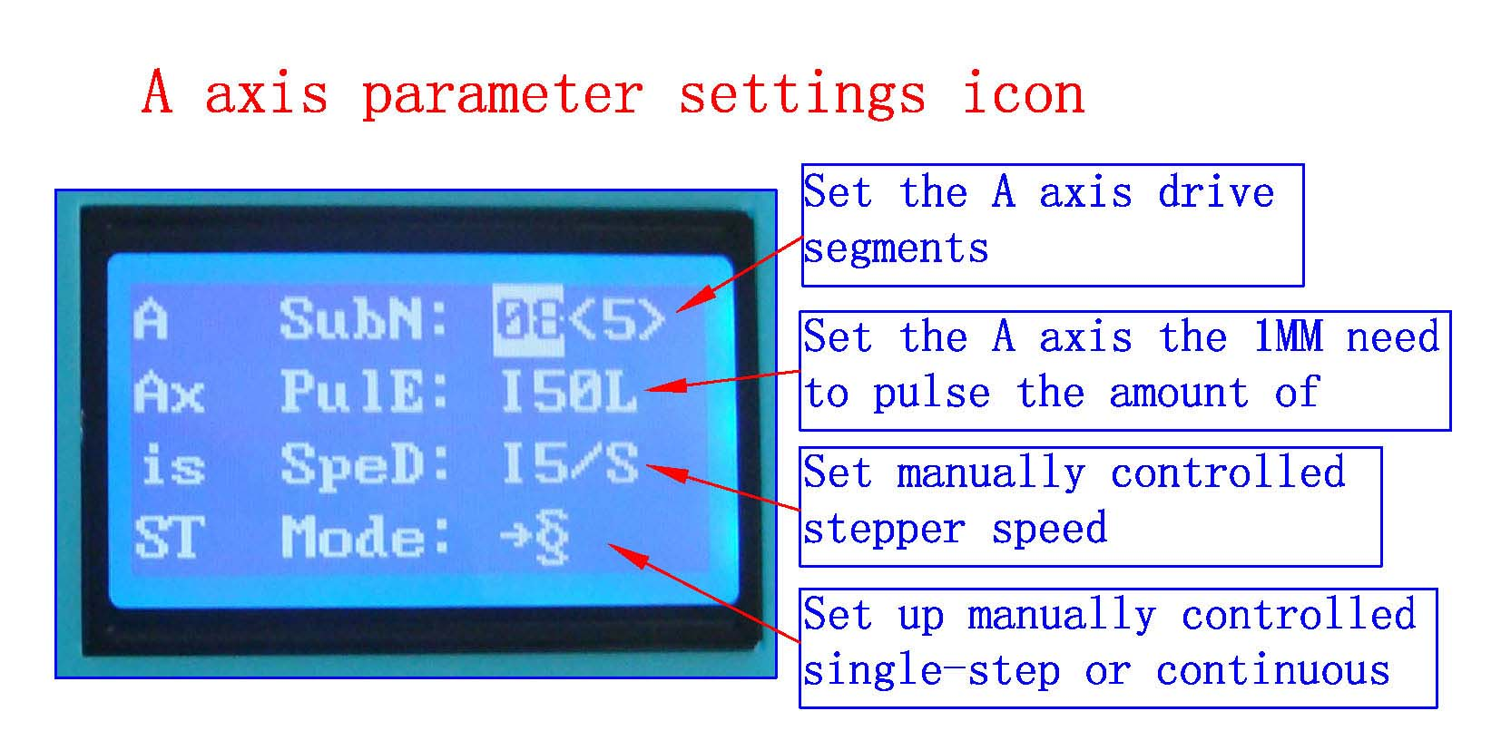
; All settings automatically saved permanently, until the next set update
1: ST button press the handle into the lower settings menu, the setup is complete press the OK button to return to the main interface of
2: shift downstream handle B1 button settings,
3: handle B2 button corresponding anti-white set at function selection
4: input handles digital keys to set the digital parameters
The following three functions for the professional version of the product features
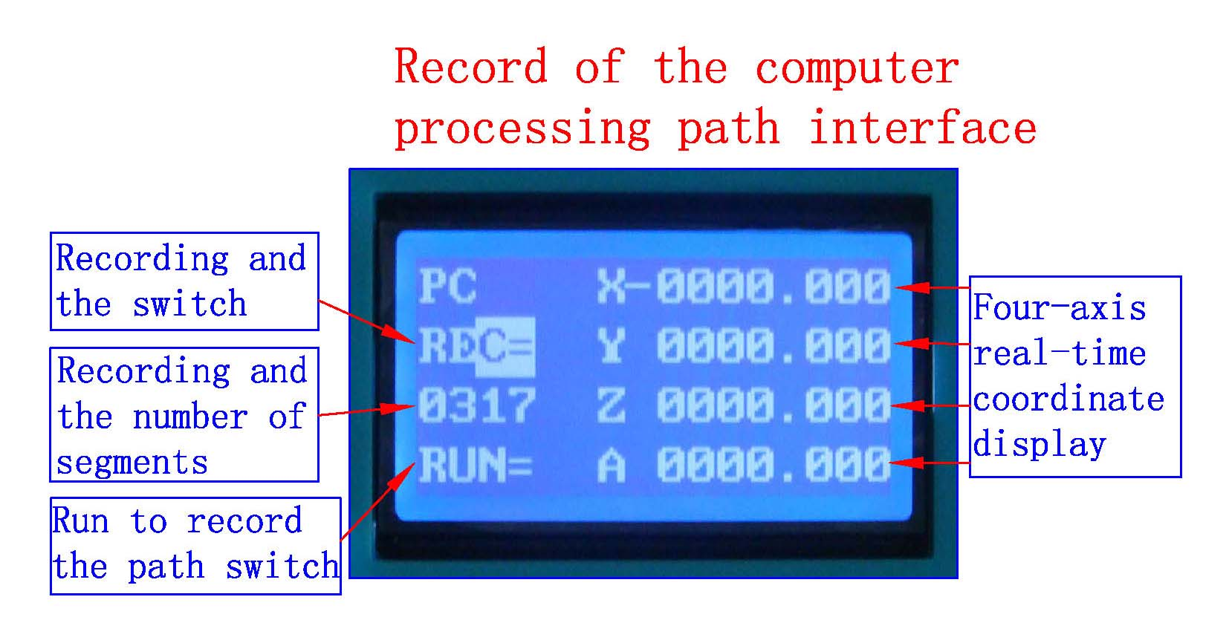
1: The coordinates of display range 0-9999.999
2: automatically records the computer running data automatically permanent preservation, to to be updated before the next recording
3: recorded 1800 segment
4: (To increase the volume can be customized plug-U disk recording the number of segments, unlimited recording)
1: display REC state B2 key to start the computer operating data record will show a record number of segments, the largest record segment 1800, then B2 button to stop.
2: B1 keys wrap to display the status RUN, then B2 key start run record keeping, computer operation data, and then the B2 key stop
3: Press the ST button to enter the lower menu setting
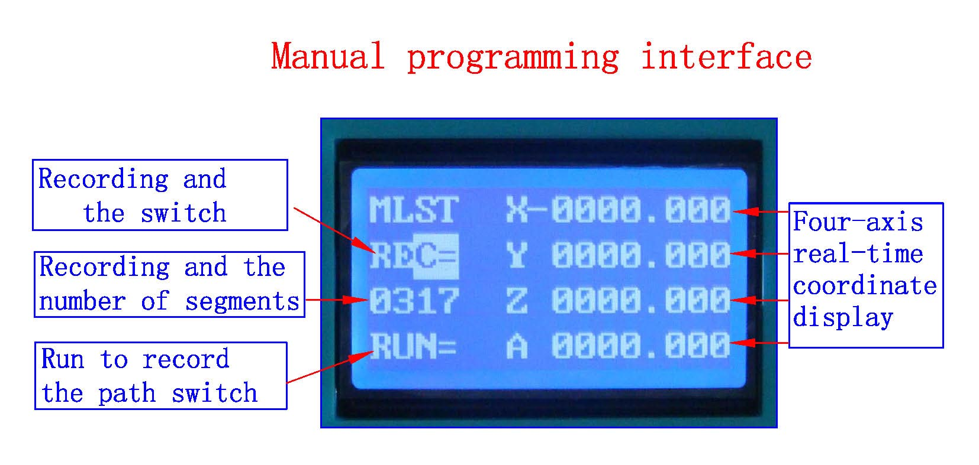
1: The coordinates of display range 0-9999.999
2: supports both digital input manually coordinate programming and manual actually moving coordinate programming
3: recorded 1800 segment
4: (To increase the volume can be customized plug-U disk recording the number of segments, unlimited recording)
1: B2 enter the run and stop the switch B1 wrap the switch
2: REC recording, press the four-axis real-time control keys to move the machine coordinates (each can only change a-axis data and then B2 key to save) save the coordinates of the real-time axis, according to the B2 key numeric keypad press the CL key to manually enter the appropriate axisinput, then B2 key to save the coordinates of the real-time axis (you can only change the axis of data B2 button to save), press B1 button to switch the recording OK to display the RUN
3: Press the OK button to exit back to the main interface
Before the test machine, please note the following
1,A test machine first to 12V voltage test machine, 42-step, please with 12-16V/DC power 57 stepper choose 16-24V/DC power, 86 stepper election 24-36V/DC power
2,the stepper motor power and current (model)
3, to determine the wiring of the stepper motor
二》The pin definitions
1》Parallel port control is defined as follows:
PIN14 | PIN1 | PIN3 | PIN2 | PIN1 | PIN5 | PIN4 | PIN1 | PIN7 | PIN6 | PIN1 | PIN9 | PIN8 | PIN16
Relay | X  Allow | X  Direction | X  Pulse | Y  Allow | Y  Direction | Y  Pulse | Z  Allow | Z  Direction | Z  Pulse | A  Allow | A  Direction | A  Pulse | 0-10VPWM

2》Limit 1 ~ PIN9 defined as follows (figures defined inside the interface marked)
X-axis limit | Y-axis limit | Emergency stop | Z-axis limit | Alternative input | DC-
InterfaceP1 | InterfaceP2 | Interface P3 | Interface P4 | Interface P5 | Interface P6-P9
Thecorresponding computerP12 | Corresponding computerP13 | Corresponding computer P15 | Corresponding computer P11 | Corresponding computer P10 | GND

3》Output interface is defined (in the picture for 1 to 22)
P1 | P2 | P3 | P4 | P5 | P6 | P7 | P8 | P9 | P10 | P11 | P12 | P13 | P14 | P15 | P16 | P17 | P18 | P19 | P20 | P21 | P22
正 | 地 | XA+ | XA- | XB+ | XB- | YA+ | YA- | YB+ | YB- | ZA+ | ZA- | ZB+ | ZB- | AA+ | AA- | AB+ | AB- | MO + | GND | GND | MO  -

Power is connected to 12 36V 8A (Optional according to the stepper motor operating current) above switching power supply, received marked on the power input interface。
12V power output is used to pick up the 12V cooling fan。
The spindle motor control is controlled through the parallel port PIN14. The spindle motor voltage must comply with the supply voltage range。
三》MACH software using the method
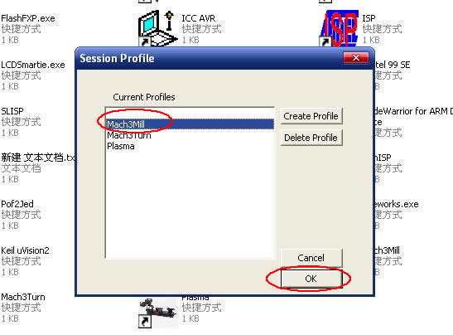
Figure1
Figure 1, open the MACH3 software, now mach3MILL then select OK
Figure 2
MACH3 open the interface shown in Figure 2, above the action button, where we first configure the MACH software。
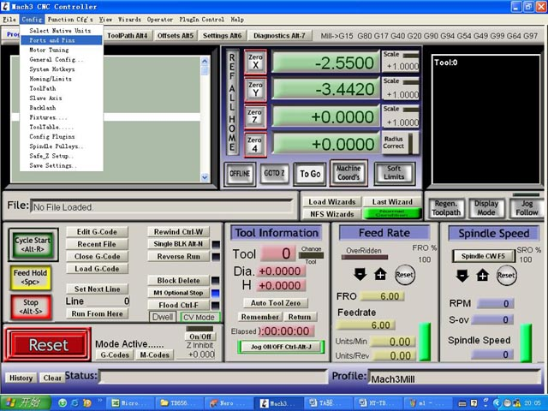
Figure 3
Figure 3, open the config menu PORT PIN menu
Figure 4
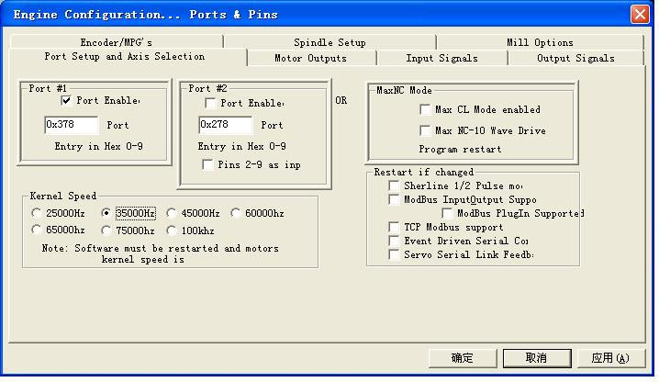
Figure 4

Set on the circle a place where you can set the fundamental frequency, this parameter of the motor rotation speed. Set up, select the circle place, the configuration of the definition of the foot, as shown in Figure5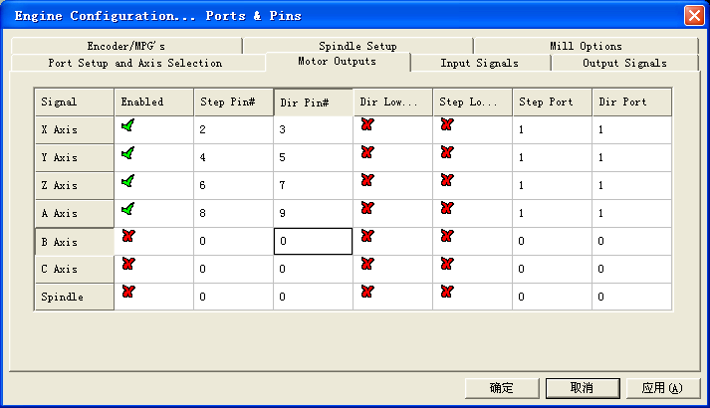

Figure5
According to the definition of the parallel port of the board, follow the map circle to indicate the definition modify the software settings。
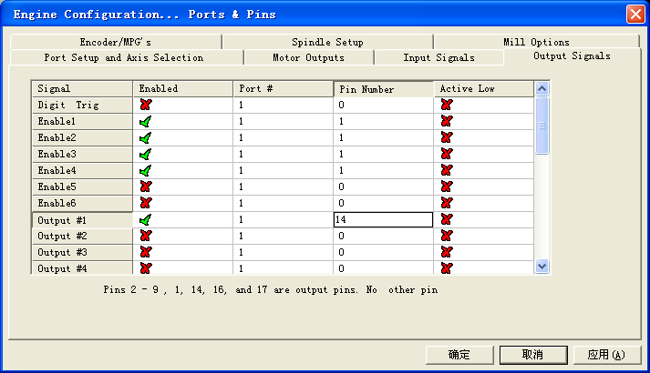

Figure 6
Then part in the selection output signals, as shown in Figure 6, according to the settings of the circle, set the appropriate。

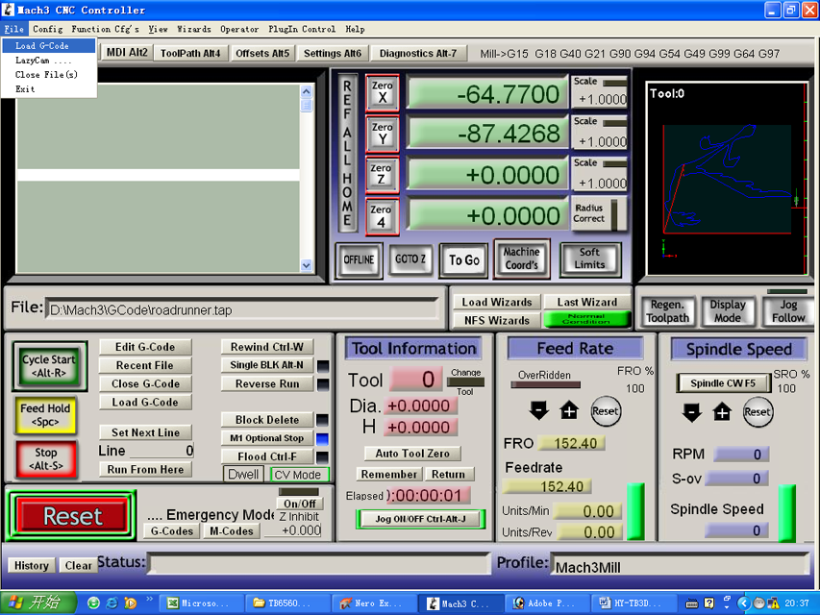
Figure 7
All set ok, you can open the G code need to run, as shown in Figure7

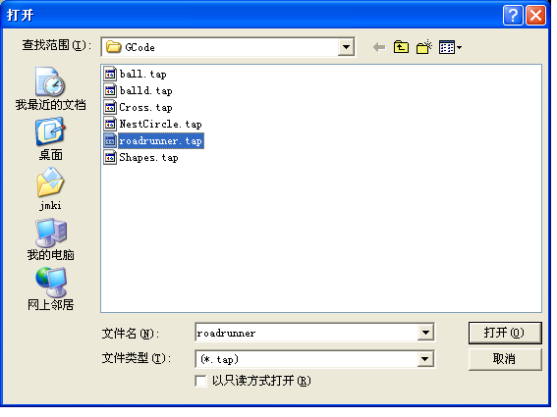
Figure 8

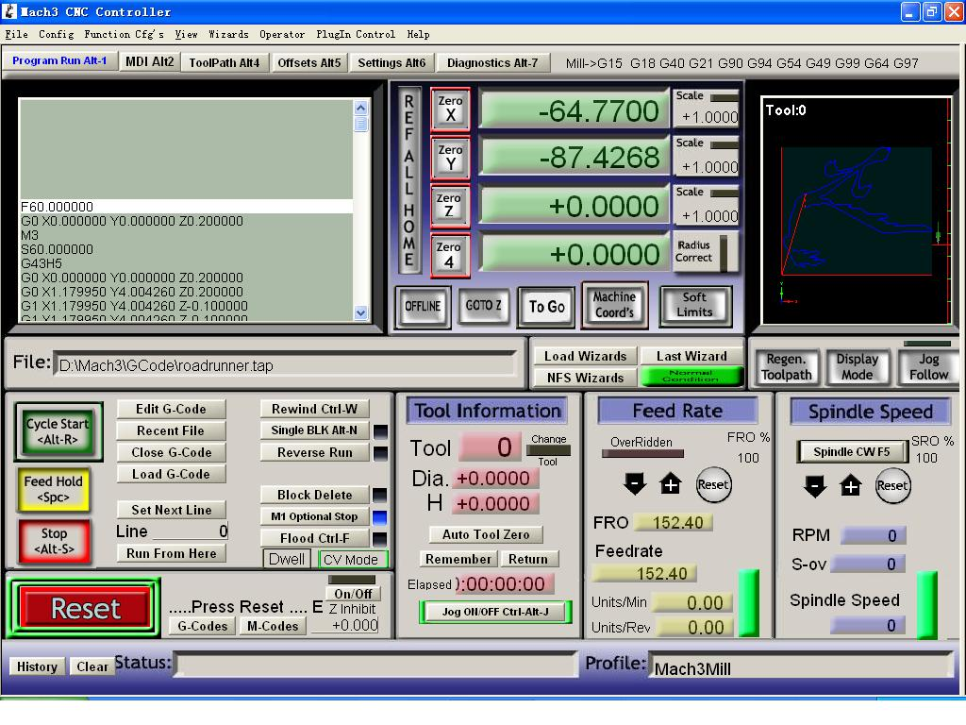
Figure 9
Open the G code, you can see the red the RESET flashing, you can use the mouse to click this RESET to stop flashing, then you can press circle the location CYCLESTART run.

